Move Out Minutes 6.2.26
6.2.2026 |  | 1-4pm EST
Team | Customer Service Team
Facilitators | Mohanta Das, Jose Diaz
Note taker | Taylor Ilov
Attendees | Service Cloud Team + SMES
Decisions/Notes:
Closed Decisions
Open Decisions – require follow up or, action items
Change Impact
Action item
~~~~~~~~~~~~~~~~~~~~~~~~~~~~~~~~~~~~~~~~~~~~~~~~~~~~~~~~~~~~~~~~~~~~~~~~~~~~~~~~~~~~~~~~~
DUPLICATE CHECK PROCESS à This likely is existing RIDA in ADO, likely Change Impact
Taylor check ADO for existing Address /DQM RIDA, Need formal follow up discussion, Jose and Mohanta talk then get back to team and we will have follow up after he is back from vacation
Duplicate check process (don’t have one currently for addresses, but can see them for all addresses)
Need to be able to see all addresses (especially for Move Out) à otherwise we will have duplicate data from Master Data perspective.

Currently have a drop down for addresses in CRM 7. This is going to be different in V2. Will have to utilize duplicate check features.

Potential Solution
It’s a problem that V2 cannot provide drop down
2 buttons? Duplicate Check for addresses and DQM

It’s not always the default mailing address on the BP.
CE has to chose to set the address as a default

Agents are adding the same address over and over again entering duplicates.
~~~~~~~~~~~~~~~~~~~~~~~~~~~~~~~~~~~~~~~~~~~~~~~~~~~~~~~~~~~~~~~~~~~~~~~~~~~~~~~~~~~~~~~~~
“Valid to” Dates (was an enhancement in ECC to fix on Move Out Date)à need to follow up
~~~~~~~~~~~~~~~~~~~~~~~~~~~~~~~~~~~~~~~~~~~~~~~~~~~~~~~~~~~~~~~~~~~~~~~~~~~~~~~~~~~~~~~~~
- Fixed Address on contract account should occur on move out date not system date
Currently in testing phase. So it will be done before Code Freeze. Fix must be correctly retrofitted into environment.

(Currently the bill is sending to the wrong address)
Move out address fix date – Digital First team doing this work now and should be completed soon, so should be corrected by time of Go-Live

1 script bringing other data sets in
~~~~~~~~~~~~~~~~~~~~~~~~~~~~~~~~~~~~~~~~~~~~~~~~~~~~~~~~~~~~~~~~~~~~~~~~~~~~~~~~~~~~~~~~~
- Don’t need photo read for V2
~~~~~~~~~~~~~~~~~~~~~~~~~~~~~~~~~~~~~~~~~~~~~~~~~~~~~~~~~~~~~~~~~~~~~~~~~~~~~~~~~~~~~~~~~
- Simplify Caller Information Screen for Move Out - Only order for Move Out will be Turn off

Only Turnoff during Move out (Meter exchange not done during Move out)
If we are only doing turnoff orders why are we asking Caller type and Person group- is there an opportunity to simplify this?

Caller Information Screen (slide 11 in deck) – heavily customized Screen. This output is based on the questions asked before which changes the fields that are being presented on the screen

During Move in Service Orders will be on Service Screen

Create Service Order à Service notifications
48 workorders from CRM, what are being consolidated that will alter decision trees in BRF+
Service Management = Out of Scope
~~~~~~~~~~~~~~~~~~~~~~~~~~~~~~~~~~~~~~~~~~~~~~~~~~~~~~~~~~~~~~~~~~~~~~~~~~~~~~~~~~~~~~~~~

- Current Occupant/ “Fake Account” = This process will stay the same for the future
Force of turnoff for commercial, residential does not have to get turned off

Workflow kicks in, goes into current occupant if it doesn’t get turned off (for residential)
For commercial there is no workflow, so they must turn it off

If we move out a real occupant, need to see “current occupant” customer next day. Processed late at night. 11:50pm

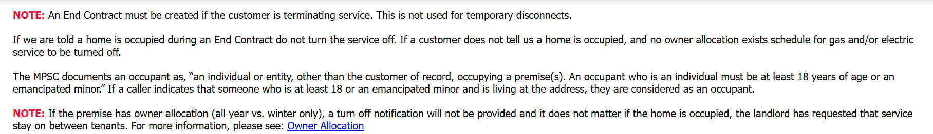

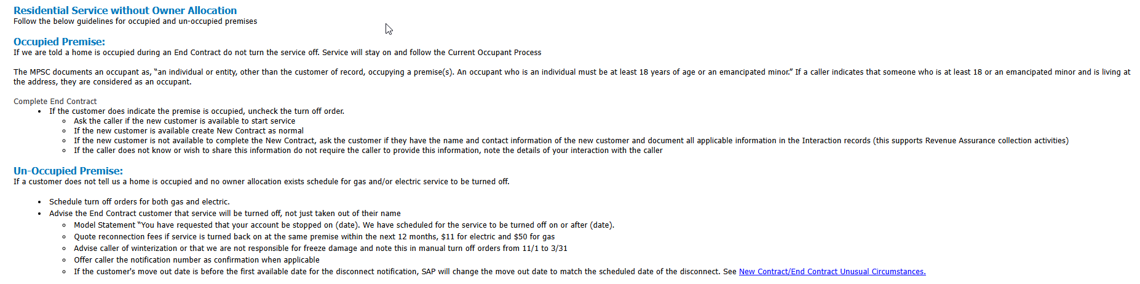
~~~~~~~~~~~~~~~~~~~~~~~~~~~~~~~~~~~~~~~~~~~~~~~~~~~~~~~~~~~~~~~~~~~~~~~~~~~~~~~~~~~~~~~~~
Taylor Add this to ADO RIDA for Address Independent / Dependent
Adding address in independent field, if it’s a new one it adds a new line, if it is one address, it just uses the one field
MUST Go to independent field
~~~~~~~~~~~~~~~~~~~~~~~~~~~~~~~~~~~~~~~~~~~~~~~~~~~~~~~~~~~~~~~~~~~~~~~~~~~~~~~~~~~~~~~~~
“Did you sell this property” – on End Contracts field, need to revisit this in the next workshop.
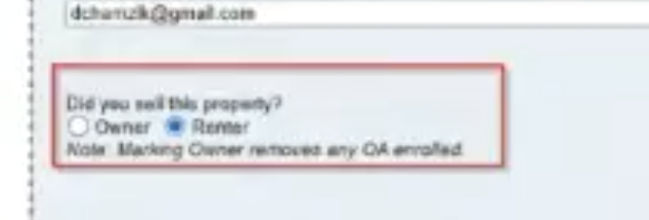

Email address on file: they get both a paper bill and e-bill only for final bill, have to be opted in in e-bill
Ebill indicator should be asked before address on the Contract Account and Billing screen.

Multiple phone numbers (currently available in ECC)

Pop up of preferences for changing address or phone number à POTENTIALLY NEW FRICE-W
Change Mailing address or phone number- preferences associated with it, will the user be told in a pop up?
Changing mobile number to a different number à currently doesn’t auto change, have to go into the preference center
1-Email address- doesn’t necessarily sync with preferences
2-Phone number
3- Did you sell this property

Shibu looking into the data behind this screen
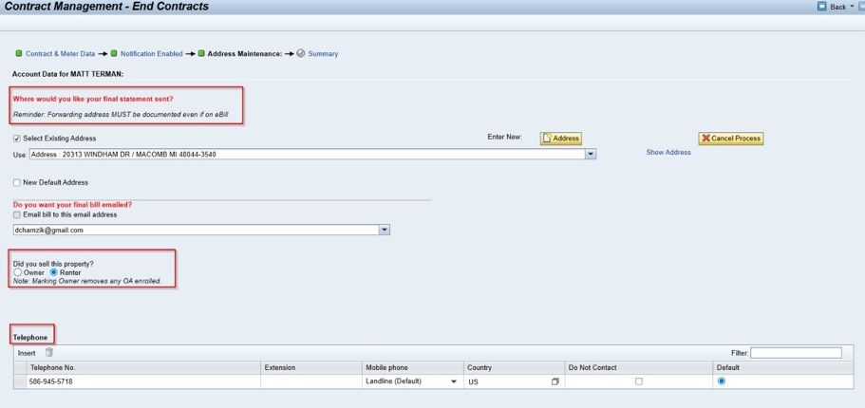

Last Screen (slide 15) – BP Summary screen
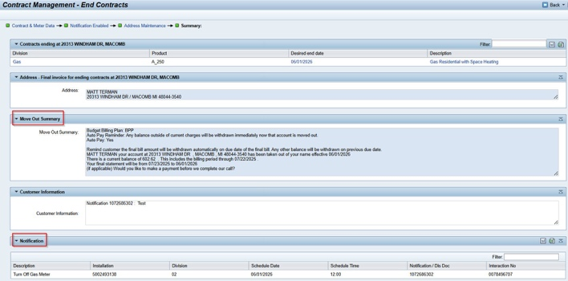

Move Out Summary
Using an existing FRICE-W Placeholder for the enhancements in this screen
Need to have more discussions on how this will look in future state
(This screen is telling the CSRs what to say / do at the end of the move in)
Text that is displaying is in CRM7 – not DRECTLY coming from ECC
~~~~~~~~~~~~~~~~~~~~~~~~~~~~~~~~~~~~~~~~~~~~~~~~~~~~~~~~~~~~~~~~~~~~~~~~~~~~~~~~~~~~~~~~~
If ASP = accout ends
If Cap Loan = acct stays on a premise, but when new person moves in the account is transferred to BP
à as long as the expiration date isn’t up, new person is assigned to this cap loan
Payment plan = everything ends

NEXT WORKSHOP:
Custom Fields associated with Premise (Cap Loan)

ZZCAPLOAN
ZZPRIORITYCOM
ZZPRIORITYREST

Cap Loan created on the same account numnber as the utility contract- part of monthly bill

I believe the CAP Loan dept manually sets up the loan on the new customer. The workflow notifies the CAP Loan dept when a MI, MO, MI Reversal and a MO Reversal occurs
- Melissa CAM – loan processing “department”

Nothing about Cap Loan process is going to change with S/4 or Service Cloud
à need to pull test scenario /user stories for SD Billing

Device Location Notes
Flows that automatically take customer off when moved out

Create Disconnect Document is part of the notification view- follow up

TAYLOR ADD TO FRICE-W Page
Smart Meter (Gas and Electric Opt in/Opt Out) replaces
21. Smart Meter Opt in / Opt Out – Discuss in Contract Change Management
+ Move out summary script = #22 on list net new

~~~~~~~~~~~~~~~~~~~~~~~~~~~~~~~~~~~~~~~~~~~~~~~~~~~~~~~~~~~~~~~~~~~~~~~~~~~~~~~~~~~~~~~~~
MOVE IN REVERSAL OVERRIDE – everyone can ovveride move ins, what’s the point
Should not be backdating move outs -> but some CSRs do Backdate move outs
Custom rules in place
Late payment charges trigger a lot of reversals
Reversed after final bill à cover in case management workshop

Custom table in ECC
~~~~~~~~~~~~~~~~~~~~~~~~~~~~~~~~~~~~~~~~~~~~~~~~~~~~~~~~~~~~~~~~~~~~~~~~~~~~~~~~~~~~~~~~~
topics need to close out this week
- Move in Override hard stop (next workshop) à % overriden based on move ins being done, Shibu
- Service Notifications (next workshop)
- Enrollments in Demand Response (for Orders Outside of Move In Move Out Process) – talk before Enrollments workshop (ADO, talk before Enrollments workshop) – existing RIDA
- Change Contract Management, reversals, owner allocation -next workshop
~~~~~~~~~~~~~~~~~~~~~~~~~~~~~~~~~~~~~~~~~~~~~~~~~~~~~~~~~~~~~~~~~~~~~~~~~~~~~~~~~~~~~~~~~
Overriding Hard Stop for Move IN – need to determine authorizations
This is all available before they start the move in
See if its based on RATE or BP

CSR has to override the hard stop. If you can’t provide the code you can’t proceed with the move in. A lot of people were provided this.

Alert in the bottom left, so that they don’t miss this
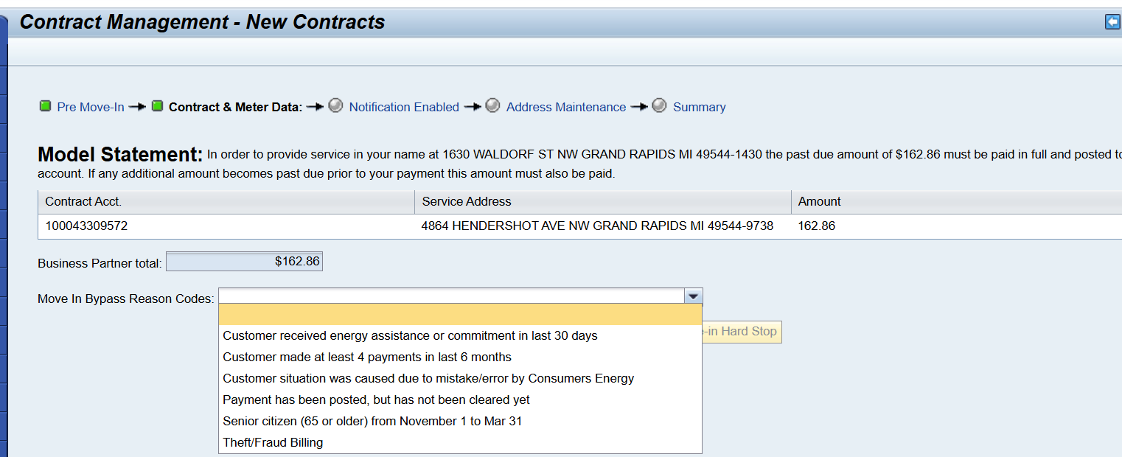

I would like to better understand the process for move in and move out for searching. This could be a large change management item for us to capture potentially. We had found the premise to do a move out. What is the concept for move in? Today we find the BP and move them into a premise, if we are to find the premise and then move a BP this I would consider a big change - We had a large gap in this space. Reps were finding the premise and then overtyping the current BP there with the new BP information in error - I'm good with however it is going to work but just the logging for change management.
~~~~~~~~~~~~~~~~~~~~~~~~~~~~~~~~~~~~~~~~~~~~~~~~~~~~~~~~~~~~~~~~~~~~~~~~~~~~~~~~~~~~~~~~~
FROM AJAY
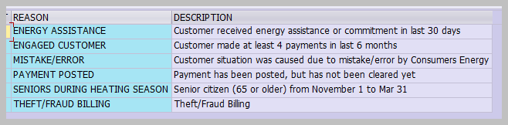
The reason codes are maintained in ECC table

Action Items |  |  |  | Person Responsible | Deadline
Duplicate Check process- Jose, Mohanta + Core Team need to talk offline on an approach then revisit in a follow up discussion |  |  |  | Jose, Mohanta | Workshop B 6/11
Need a Follow Up discussion on “Valid to” Dates - Core team discuss then assess if follow up needed |  |  |  | Dawn, Tarah, Core Team | Workshop B 6/11
Pop up of preferences for changing address or phone number à POTENTIALLY NEW FRICE-W |  |  |  | Jose, + Core Team | Workshop B 6/11
NEXT WORKSHOP:  Custom Fields associated with Premise (Cap Loan) |  |  |  | Mohanta, Taylor | Workshop A-3 6/4/23
Create Disconnect Document is part of the notification view |  |  |  | Tarah + Core Team | Workshop B 6/11
TAYLOR ADD TO FRICE-W Page  Smart Meter (Gas and Electric Opt in/Opt Out) replaces  21. Smart Meter Opt in / Opt Out – Discuss in Contract Change Management  + Move out summary script = #22 on list net new |  |  |  | Taylor | Workshop A-3 6/4/23
Taylor Add this to ADO RIDA for Address Independent / Dependent  Adding address in independent field, if it’s a new one it adds a new line, if it is one address, it just uses the one field  MUST Go to independent field |  |  |  | Taylor | Workshop A-3 6/4/23
topics need to close out this week  - Move in Override hard stop (next workshop) à % overriden based on move ins being done, Shibu  - Service Notifications (next workshop)  - Enrollments in Demand Response (for Orders Outside of Move In Move Out Process) – talk before Enrollments workshop (ADO, talk before Enrollments workshop) – existing RIDA  - Change Contract Management, reversals, owner allocation -next workshop |  |  |  | Mohanta | Workshop A-3 6/4/23

